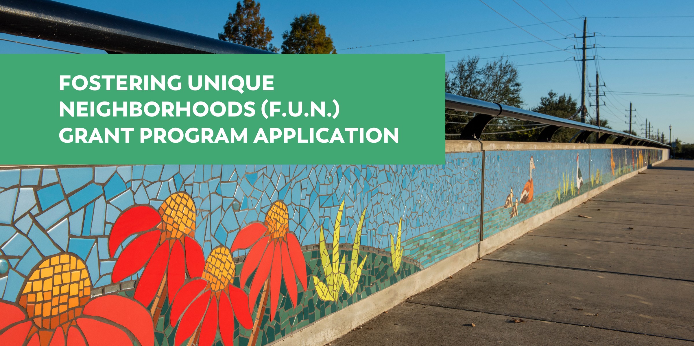

PROJECT DETAILS
ABOUT
Through partnerships with neighborhoods and community groups, the Fostering Unique Neighborhoods Grant Program exists to empower community groups, such as homeowners associations (HOAs), property owners associations (POAs), and recognized community groups (RCGs), to revitalize and create unique places that reflect the distinct character of each neighborhood or area of commerce. These partnerships will promote economic development and workforce retention & attraction through the transformative power of placemaking, mobility, and beautification that will enhance the quality of life for the community.

PROGRAM GOALS
- Beautify Sugar Land's Neighborhoods and Areas of Commerce (such as the Sugar Land Business Park for the business community or Sugar Land's office park areas) with lasting public art installations and aesthetic improvements, such as murals, mosaics, modern signage, public art, wayfinding improvements and more
- Promote Economic Development by creating places and quality of life improvements that will help retain and attract Sugar Land's workforce and attract new business
- Develop Public Spaces with community amenities for all to enjoy, such as parklets and pocket parks
- Create Inviting Outdoor Spaces by creating new mini parks or green spaces
- Preserve and Celebrate the Distinct Character of Sugar Land's Single-family Neighborhoods
- Innovate with transformative public projects that the City has not seen before

FUNDING
Fiscal Year 2023 budgeted funds are $200,000.

APPLICATION DEADLINE
Applications open October 1, 2023 and closes November 30, 2023.

2023 GRANT APPLICATION INSTRUCTIONS
- Before applying, please review the program policy on the Program Webpage. This policy describes the qualifications and requirements to apply to the program.
- Also, please also review the Program Webpage for full details on the program as well as an FAQ section that answers frequently asked questions.

ADDITIONAL PROGRAM GUIDELINES
- A survey showing the location of the fence and any encroachments is required for perimeter fence projects.
- Organizations will be notified of the grant decisions following the December 2023 or January 2024 SL4B Meeting. Organizations will be notified of the grant decisions following the December 2023 SL4B Meeting or January 2023 SL4B Meeting.
- Projects that are started prior to receiving a notice to proceed from the City as well as an executed agreement will not be reimbursed.

APPLICANT INFORMATION

Organization/Group: _______________________________________________________________________
Name (will be City’s point of contact for application process): __________________________________________
Address: _______________________________________________________________________
Phone: _____________________________ Email: _________________________________
Organization Type:
__Homeowners Association __Property Owners Association__ Recognized Community Group*
*If you are applying as a Recognized Community Group or a Homeowners Association, please register with the Office of Communications and Community Engagement by using the Neighborhood Registration form, located on the City’s website in the Form Center or by going to https://www.sugarlandtx.gov/1774/Neighborhood-Registration
PROJECT INFORMATION
Project Title: ______________________________________________________________________________
Project Location: ___________________________________________________________________________

Is the project located within city limits? _________ (Yes/No)
Is the project located on public property or easement? ________ (Yes/No)
Project Description/Scope/Justification (If project is on private property, please describe how the project is a public benefit): ___________________________________________________________________________________
___________________________________________________________________________________
___________________________________________________________________________________
___________________________________________________________________________________
___________________________________________________________________________________
___________________________________________________________________________________
___________________________________________________________________________________
___________________________________________________________________________________
___________________________________________________________________________________
___________________________________________________________________________________
_____________________________________________________________________________________

Project Cost | Amount | % of Total Cost
Requested from SL4B | $ | %
Organization Participation | $ | %
Other Sources of Funding | $ | %
Estimated Total Project Cost | $ | 100%

List additional funding sources:
___________________________________________________________________________________
REQUIRED DOCUMENTS
Please include the following required supporting documentation with the application:

- Clear color photos and/or renderings of the proposed project
- Clear color photos and/or renderings of the current project location
- Work Estimates/Quotes showing the cost of the project
- Financial Documents that show financial ability to fund your share of the project costs
- Survey showing exact location where perimeter fence will be located (Required for perimeter fence projects)
- Site Plans
- Scope of Work
- Map of project location

Any additional documentation not listed that the applicant can provide to strengthen the application is recommended.

SIGNATURE

Name: ________________________________
(Organization President or Designee)

Signature: _____________________________
Date: __________________

PLEASE SEND COMPLETED REQUEST FORM TO

Email:
JCIP@sugarlandtx.gov
cc jsoriano@sugarlandtx.gov

Application submissions must be emailed in pdf format in zipped files.

TO BE COMPLETED BY CITY OF SUGAR LAND, OFFICE OF ECONOMIC DEVELOPMENT

Date Received: ___________________________ Complies with City Polices & Standards? ________
Reviewed By: _____________________________ Date Reviewed: _____________________________

Top of Form
Bottom of Form

